5. Web application

5.1 Introduction to Web Applications
A web-application is an application program that is usually stored on a remote server, and users can access it through the use of Software known as web-browser. Web application is a piece of software that can be accessed by the browser. A Browser is an application that is used to browse the internet. Web application needs authentication. The web application uses a combination of server-side scripts and client-side scripts to present information. It requires a server to manage requests from the users.
Example: Google Apps, Amazon, YouTube
It is a type of computer program that usually runs with the help of a web browser and also uses many web technologies to perform various tasks on the internet. A web application can be developed for several uses, which can be used by anyone like it can be used as an individual or as a whole organization for several reasons.

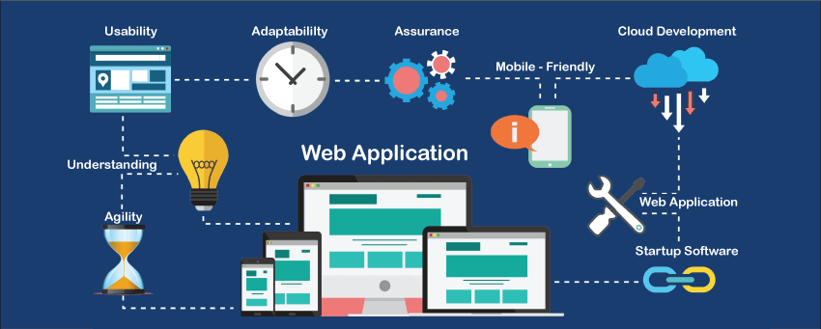

If we talk about the web application in general, a web application usually uses a combination of the server-side scripts such as PHP, ASP, for handling the information/ data storage and retrieval of the data. Some of them also use the client-side scripts such as JavaScript, HTML to represent the data/information in front of the users, and some of the web applications are also using both server-side and client-side at the same time.
How Does It Work?
With any typical web application, there are two different codes (sub-programs) running side-by-side. These are:
- Client-side Code - The code that is in the browser and responds to some user input
- Server-side Code - The code that is on the server and responds to the HTTP requests
A web developer (team) developing the web application decides as to what the code on the server will do with respect to the code in the browser. For writing server-side code, C#, Java, JavaScript, Python, PHP, Ruby, etc. are used.
Any code that is able to respond to HTTP requests has the ability to run on a server. The server-side code is responsible for creating the page that the user requested as well as storing different types of data, including user profiles and user input. It is never seen by the end-user.

5.2 Platforms used for Web Applications
As the web application space expands, the way of building a feature-rich application gets considerably complicated. It can be a daunting task to choose the right platform for your next web development project as a wide range of frameworks are introduced in the market with varied framework architecture. Ranging from open source to paid technologies, the options are overwhelming and at times, confusing.
Here is the list of some suitable Platforms for your Web Applications.
Angular JS
AngularJS Framework developed By Google It was first released in 2009, and completely rewritten in 2016. Angular. JS is a powerful JavaScript-based development framework. It is an open-source framework. This Framework is used by companies like Google, Paypal, Netflix, Upwork, Microsoft and other Giants.

AngularJS can be Considered the best Front-end framework for a web application. Angular JS is great for Video Streaming Apps, Travel Apps, Weather Apps, eCommerce, Mobile Commerce, Social Apps, User-Review Applications. It is used to create dynamic web applications. Angular Implements the MVC method.
AngularJS is a JavaScript framework. It can be added to an HTML page with a <script> tag.
AngularJS extends HTML attributes with Directives, and binds data to HTML with Expressions.

React JS
ReactJS is a declarative, efficient, and flexible JavaScript library for building reusable UI components. It is an open-source, component-based front-end library which is responsible only for the view layer of the application. It was initially developed and maintained by Facebook and later used in its products like WhatsApp & Instagram.
The main objective of ReactJS is to develop User Interfaces (UI) that improves the speed of the apps. It uses virtual DOM (JavaScript object), which improves the performance of the app. The JavaScript virtual DOM is faster than the regular DOM. We can use ReactJS on the client and server-side as well as with other frameworks. It uses component and data patterns that improve readability and helps to maintain larger apps.
ASP.net
ASP.NET is a web application framework developed and marketed by Microsoft to allow programmers to build dynamic web sites. It allows you to use a full featured programming language such as C# or VB.NET to build web applications easily.
ASP stands for Active Server Pages.
Node.js
Node.js is the best when you build a highly efficient website. It is a very powerful JavaScript-based platform. You can develop web applications like video streaming sites, single page applications, and many other applications. As technology is changing developers are moving to adopt convenient frameworks for their web development needs.
- It is an open-source server environment.
- It runs on various platforms (Windows, Linux, Unix, Mac OS X, etc.)

5.3 Components of Web Applications

5.3.1 Application Server
A web server accepts and fulfills requests from clients for static content (i.e., HTML pages, files, images, and videos) from a website. Web servers handle HTTP requests and responses only.
An application server exposes business logic to the clients, which generates dynamic content. It is a software framework that transforms data to provide the specialized functionality offered by a business, service, or application. Application servers enhance the interactive parts of a website that can appear differently depending on the context of the request. Application server contains web and EJB containers. It can be used for servlet, jsp, ejb etc.
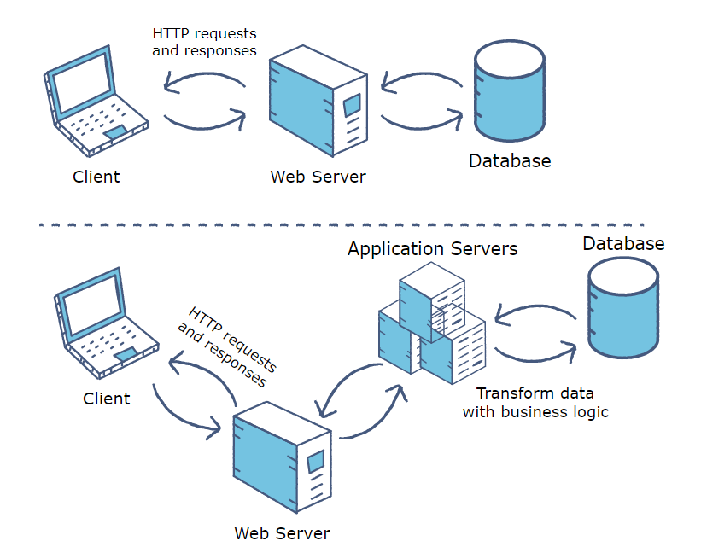

5.3.2 Database Server
Database servers are networked computers on a network dedicated to database storage and data retrieval from the database. The database server is a key component in a client/server computing environment. It holds the database management system (DBMS) and the databases. Upon requests from the client machines, it searches the database for selected records and passes them back over the network.
A database server can be defined as a server dedicated to providing database services.
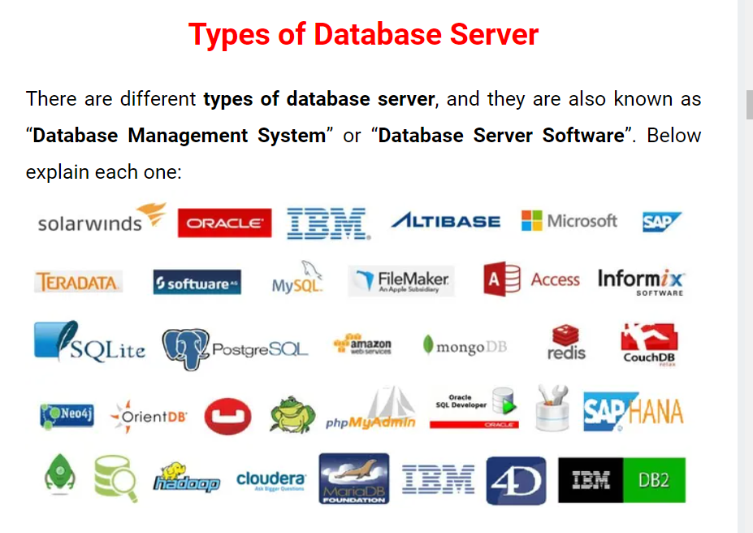

5.3.3 Web Browser
A web browser is a software program that allows a user to locate, access, and display web pages. In common usage, a web browser is usually shortened to "browser."
Web browsers are used primarily for displaying and accessing websites on the internet, as well as other content created using languages such as Hypertext Markup Language (HTML) and Extensible Markup Language (XML).
Browsers translate web pages and websites delivered using Hypertext Transfer Protocol (HTTP) into human-readable content.
- The main function is to retrieve information from the World Wide Web and making it available for users
- Visiting any website can be done using a web browser. When a URL is entered in a browser, the web server takes us to that website
- Multiple webpages can be opened at the same time on a web browser

5.3.4 Connecting Web Application to Database

PHP and MySQL
PHP and MySQL are like two different sides of the same coin. Just like MySQL has built in functions for data manipulations, so does PHP has built in functions for connecting to MySQL server and manipulating the data in the database. Let’s now look at some of PHP functions that allow us to manipulate MySQL databases
MySQL connect
$dh = mysql_connect(servername,username,password);
HERE
- “mysql_connect” is the PHP built in function for connecting to MySQL database
- “servername” is the name of the server running MySQL server.
- “username” is the name of the user that we will use to authenticate ourselves when connecting to the server.
- “password” is the password that we will use to authenticate ourselves when connecting to the server.

PHP Data Object [PDO]

Alternatively we can also use the PHP Data Object PDO to connect to MySQL server. It has the following basic syntax.
$dbconn = new PDO(mysql:host=servername;dbname=databasename,username,password);
HERE
- “dbconn” is the database connection object that we can use to manipulate our database.
- “new PDO (…)” creates an instance of the PDO class.
- “mysql:host=servername;” is the name of the server running MySQL server.
- “dbname=databasename” is the name of the database to be manipulated from PHP.
- “username,password” are login credentials we will use to authenticate ourselves.

5.3.5 Accessing and retrieving data and values from database

Structured Query Language (SQL) is a specialized language for updating, deleting, and requesting information from databases.

An SQL SELECT statement retrieves records from a database table according to clauses (for example, FROM and WHERE) that specify criteria. The syntax is:
SELECT column1, column2 FROM table1, table2 WHERE column2='value';

